CAPACITY DISPLAY SETTING PROCEDURE

Note: | In units with software version LT2.8 and higher, the capacity display can be switched on or off in the battery menu. The red KIK key has to be used for this.  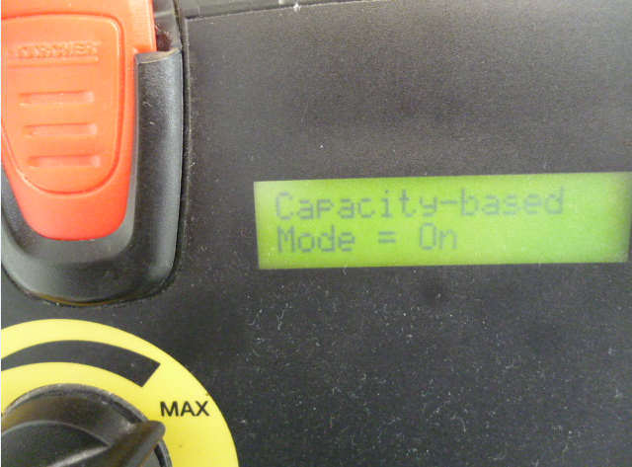  The battery indicating instrument works either according to the voltage or capacity display (balancing).  1. Voltage display  The voltage display is active after the following statuses if:  - the battery is connected to the machine  - a new curve is selected from the battery menu  The voltage display can be identified by the dot next to the bar code.  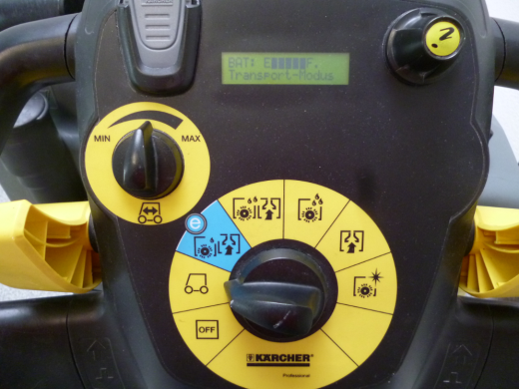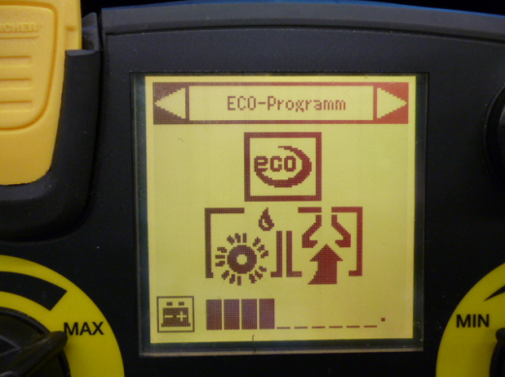  B 40 C/W and B 60 W B 80W and B 120 W  Regardless of the available battery capacity, the voltage display changes to the capacity display automatically after the next charging procedure, on condition that charging took place completely without interruption. The display says "Charge complete".  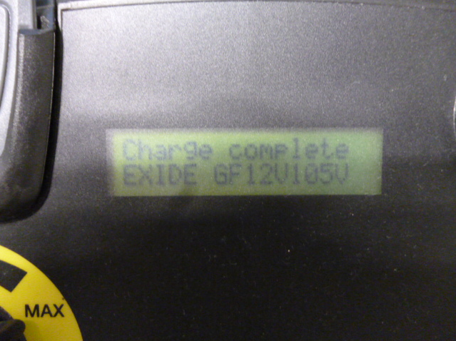  2. Capacity display  The unit is in the capacity display if there is no dot next to the bar code.  The electronics module does not yet know how much battery capacity is available and therefore works initially according to a defined capacity that is documented.  The following values are stipulated for:  B 40 C/W and B 60 W 60 Ah  B 80 W 118 Ah  B 120 W 190 Ah  In other words, for automatic calibration to take place, the unit has to be completely discharged until the brush motor and the suction motor switch off.  To this end, please ignore the instruction "Recharge Battery".  Then recharge the battery fully without interruption.  After this measure, the capacity display will be adjusted to the existing battery.

Note: | B 40 C  The current software is V2.9. It contains the same improvements as for B 40 W.
B 40 W, B 60 W, B 80 W
The current software is V2.8. It contains the following improvements:
- The capacity mode (balancing) can be switched on or off in the battery menu as needed. The red KIK key has to be used for this purpose.
=> Default setting: capacity mode is switched off.
Important note: The battery display is in voltage mode when the capacity mode is switched off. We have now discovered a software error in this display. In other words, when the battery is fully charged the display only shows a half-charged battery.
This fault will be eliminated with the next software update.
To bypass the problem, switch the capacity mode on in the battery menu.
 | 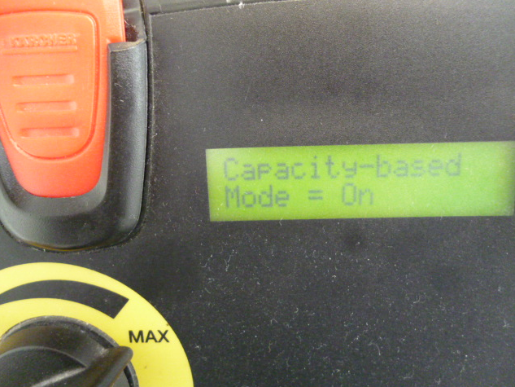
- Standby switching is also integrated when the KIK key is plugged into the unit.
- Maintenance intervals readjusted.
  - first maintenance after 200 hours
  - every further maintenance after 400 hours

